Our Product Design Process:
At Synectiks Inc, we’re used to adapting our process to meet client goals. We are also fierce advocates of user feedback and human-centered design.

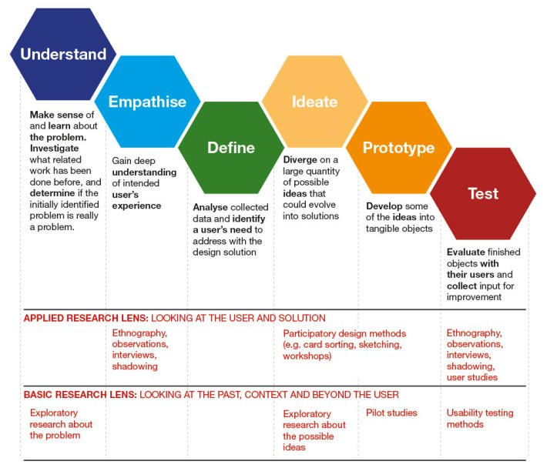

In general, our design process starts at low fidelity, often paper or whiteboard sketches, and progressively moves toward deliverables that define the structure and layout of the site or application such as site maps, workflow diagrams, and wireframes. Throughout the process, prototyping serves as a sandbox for validating design solutions, and as a vehicle for user feedback.

How We Organize UX Design Process at Synectiks
Step One of the UX Process:
The visible part of our UX design process starts when we first get in touch with a new client. In this early stage we try to get as much information as we can. We are eager to find all hidden skeletons (desires, barriers, deadlines, preferences, etc.) that could cause any inconveniences in case they pop up later. It is important to look for these skeletons in the very beginning of the UX design process so we can find solutions for them, too. In order to be the best detectives, we do these things:
- Pre kick-off questions
In the interest of being able to properly prepare for the kick-off meeting we send the client a few general questions. These questions are in connection with their target audience, their competitors and existing design materials as well as the roles of the project members.

- Kick-off meeting
It is an approximately 2 hour long meeting where we go through some questions regarding further requirements of the customers, we start building hypothetical customer & user journeys and create hypothetical personas (who are the users and what do they need). We also hold a so-called “Style and brand persona workshop” (what would your brand/product look like if it were a person?).

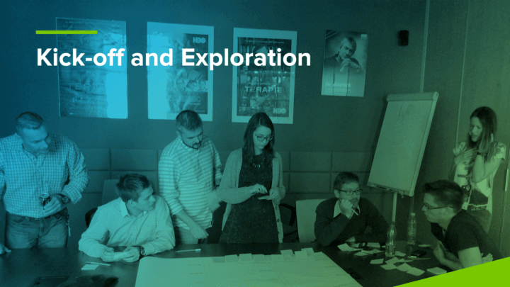

Step Two of the UX Process:
So, after we gather and organize the information we got… well, we dig deeper for some more.
In the UX design process it is the time when we collect as much information as we can, to get the knowledge that we could not get during the kick-off. We usually do a 7 day long preliminary research where we…

- Set up interviews with users of the target group to validate personas and complete the customer & user journeys.
- Research the competitors, get information about features, advantages and disadvantages.
- Design mood boards for the product
- Schedule the project tasks in detail (weekly plan for at least 2 months and milestones for the rest of the project)

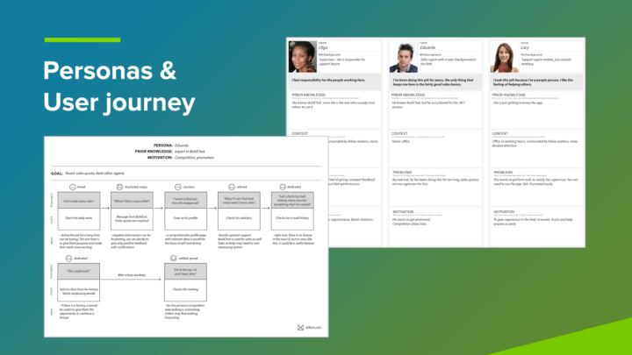

It is our best interest to have these tasks in our UX design process, so we can continue our work with a very strong knowledge base. To give all the ideas we have a really visual and tangible form, now we start our fun part: the prototyping and usability testing phase!

Step Three of the UX Process:
Prototyping & Usability testing
Our UX process wouldn’t be the same without the good old teamwork of a designer and a researcher – usually the team consist of them, but some projects require more designers or maybe more researchers. First the designer creates the sketches and the prototype form it, which the researcher tests. We always show everything to the client the moment it’s ready, as it is the most important thing that they know about the UX design process steps. Here are the details about this phase:
- Sketching
We always start with sketching. It is the easiest way of visualizing our ideas.

- Prototyping
When we have a few good ideas and know how the main structure of the application will look like we start building a wireframe and the prototype.

- User testing
We at Synectiks work with 1 week design sprints. Usually we have a client meeting in the beginning of the week, where we show all the main results of the tests. After this we can agree on the modifications of the design, that will be tested in the second part of the week. Testing in many iterations is a must-have when it comes to prototypes. That is why the iteration phase takes at least a few weeks. We always validate our ideas based on tests with real users. During the UX design process it’s very important to understand that the product is for the users and not vice versa.

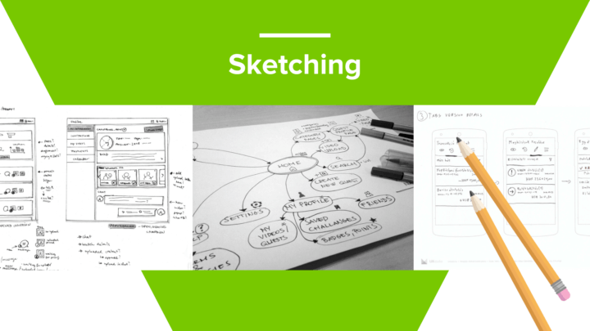
Step Four of the UX Process:
Detailed design & A/B testing
Now we can step into our UX process’s next phase when we create the nice looks!

- Detailed design
The next step of our UX design process is when we design all the pixel perfect screens in Adobe XD or Figma. However, we like to learn new tools, so the design software’s each of us uses can be quite diverse.

- Creating specification
We always create some sort of specification for the developers. A UI kit is always a must-have. We usually create animations for the interactions as they can be used for showing great things to the clients, but it’s a very helpful asset for the developers as well.

- A/B testing
We usually use A/B testing to decide which version of the app is better and to get a higher conversion rate.

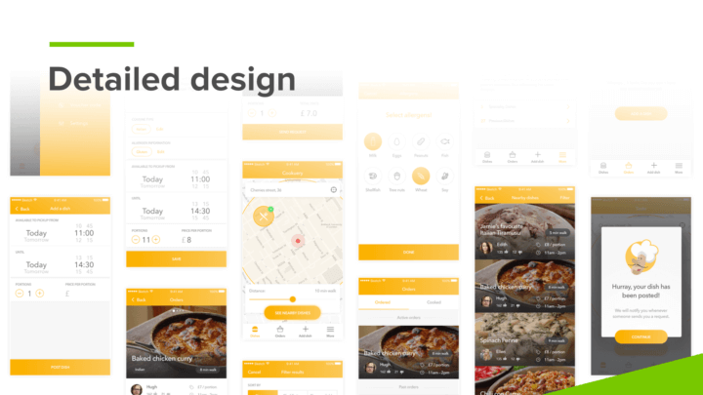

Step Five of the UX Process:
Follow-up
We like it when the product goes in the right direction. We want to be sure that the application is implemented the way we designed it for a great user experience. There are two possibilities:

- If the development process is parallel with the design, it’s quite easy to follow what’s being built as we communicate with the client/the developers on a daily basis.

- But if the development process is after the design process, we usually have to schedule post-design meetings where we look at the product being developed from a UX perspective.

Well, this is how we do it. This is our ideal UX process

